Midlothian
Mrs Jennifer Allison  HEAD TEACHER  Telephone: 0131 271 4570  Email: bonnyrigg_ps@midlothian.gov.uk | 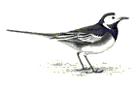 | BONNYRIGG PRIMARY SCHOOL  COCKPEN ROAD  BONNYRIGG  MIDLOTHIAN  EH19 3HR

Dear Parent/Carer

Name - ____________________________

Class - _____________________________
Milk money for the term 23rd October to 22rd December 2017 of £7.00 per child is now due. Could you please forward this to school by 30TH October. Any cheques should be made payable to MIDLOTHIAN COUNCIL. Please also complete the form below and return the monies as confirmation of payment.

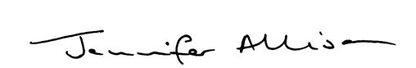

Jennifer Allison
Head Teacher

MILK DUE 23rd OCTOBER TO 22nd DECEMBER 2017

NAME - _______________________________

CLASS - _______________________________

I enclose payment of £7.00 per child

SIGNATURE ____________________________

