Curriculum
Booklet
SECOND LEVEL: PRIMARY 6B
Miss Fraser
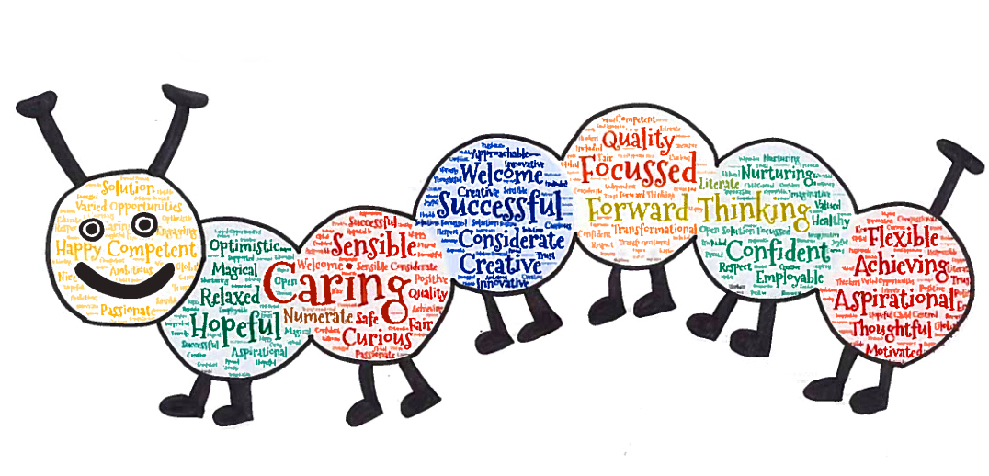
Location

Primary P6B is located in Room 3 in the Upper Atrium

Our Class
This year, the members of our class are:

Joseph Shahzaib David Kieran
Rose Kayla Sophie Alistair
Ava Layla Christie Gabriel
John Logan Cameron Jack
Daisy Bailie Aiden M Freddy
Lewis Isla William Aidan R
Olivia Lily Grace Chelsea
Orla Ryan

Specialist Teachers
Mrs McInroy teaches music on a Monday.

Other Adult Helpers
- Mrs Crowe
- Mrs Cairns
- Mrs Hay
- Mrs Anderson
- Mrs Downie
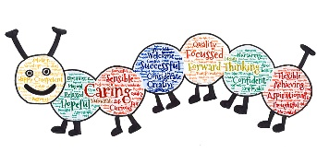
CURRICULUM FOR EXCELLENCE
This booklet is designed to inform you of the curriculum. Your child will study at Second Level of Curriculum for Excellence.
Curriculum for Excellence establishes clear values, purposes, and principles for education from 3 – 18 in Scotland. It sets out to enable children and young people to develop their capacities as successful learners, confident individuals, responsible citizens and effective contributors.
The key methods by which we will develop these capacities are through;
- active learning
- interdisciplinary learning
- outdoor learning
- co-operative learning
We will be using a range of Assessment is for Learning techniques including:
- sharing learning intentions and success criteria
- high quality interactions and feedback
- learner involvement in reflection,
- setting learning goals and next steps
- self and peer assessment
The curriculum is now divided into the following levels:
Level | Stage
Early | Pre – school and P1 or later for some
First | To end of P4 but earlier or later for some
Second | To end of P7 but earlier or later for some
Third and Fourth | S1 –S3 but earlier for some  The fourth level broadly equates to SCQF Level 4
Senior Phase | S4 – S6 and college or other means of study
HEALTH & WELLBEING

Learning in Health and Wellbeing enables children and young people to balance physical, mental, emotional, and social health.
For example:
- experience challenge and enjoyment
- experience aspects of healthy living and activity
- establish a pattern of health and wellbeing
- make informed decisions in order to improve their mental,
- emotional, social and physical wellbeing.

Physical Education
Suitable gym kit should be worn on your child's P.E. day. Some sessions may take place outside so please make sure your child is dressed appropriately.

Health and Wellbeing
Due to the ongoing COVID-19 pandemic, we will be undertaking a Recovery and Resilience curriculum topic. This will be based on several approaches which put Building Resilience and Recovery at the forefront of teaching and learning and will support all children as we focus on how we have coped and are still coping.

LITERACY & LANGUAGES

Reading, Writing, and Listening and Talking
Reading, Writing, and Listening and Talking are skills essential for successful learning, for life and for work. We are fully committed to ensuring our children develop these skills to the very best of their ability. Throughout the year your child will develop skills in:
Listening – in a group, for information and for instructions as well as developing skills in listening to others and responding appropriately.
Talking – your child will be encouraged to develop fluency, confidence and clarity when talking in a variety of situations. Opportunities to do so will be on an informal everyday basis such as sharing experiences and feelings, responding to texts and personal talks.
Reading – your child will read every day, whether in a reading group, as part of class lessons or during opportunities for reading for enjoyment, such as using the classroom library. We encourage children to develop a passion for reading by exposing them to a variety of texts, authors, and genres.
Writing – different purposes and audiences will be taught and explored throughout the year and will be incorporated into other curriculum areas. Skills will be developed in personal, imaginative, and functional writing. A high standard of presentation of written work is expected of your child.

Modern Languages
In Primary 6 children will have a weekly Modern Language lesson. During lessons the children will develop their spoken and written vocabulary.
NUMERACY & MATHS

Numeracy & Maths will be developed both in specific lessons and through activities in other areas of the curriculum.
Learning through Numeracy and Maths enables children and young people to:
- develop essential numeracy skills, including arithmetical skills, which allow them to participate fully in society
- develop a secure understanding of the concepts, principles and processes of mathematics and apply these in different contexts, including the world of work
- have an understanding of the application of mathematics, its impact on our society past and present, and its potential for the future
- establish firm foundations for further specialist learning, including for those who will be the mathematicians of the future
Children will have experiences of Numeracy and Maths on a daily basis. Problem solving will be integrated into many areas of Maths and Numeracy. Mathematical skills will be consolidated and revisited through many other areas of the curriculum to encourage children to apply the skills which they have learned.

RME
In RME children will be:
- learning about the values and beliefs of Christianity and other world religions
- developing respect for others and an understanding of beliefs and practices which are different from their own
- looking at the values and practices of different world religions, comparing these to their own values and beliefs
Our school focuses on Christianity, Islam, and Hinduism.

TECHNOLOGIES
The outcomes covered through Technologies include computing, food, textiles, craft, design, and engineering. Technologies allow children to be informed, skilled, thoughtful and enterprising citizens.
For example:
- have an understanding of the role and impact of technologies
- take responsibility for ethical actions throughout their day to day lives
- be capable of making reasoned choices
Digital technology will be integrated into your child’s learning and the children will have the opportunity to consolidate and develop new skills on a regular basis.
SCIENCES

In Science children will:
- develop a curiosity and understanding of their environment and their place in the living, material, and physical world
- demonstrate a secure knowledge and understanding of the big ideas and concepts of the sciences
- develop skills for learning, life and work
- recognise the role of creativity and inventiveness in the development of the sciences
- develop an understanding of the Earth’s resources and the need for responsible use of them
- develop skills of scientific inquiry and investigation using practical techniques.

SOCIAL STUDIES
In Social Studies children will:
- develop their understanding of the history, heritage and culture of Scotland, and an appreciation of their local and national heritage within the world
- broaden their understanding of the world by learning about human activities and achievements in the past and present
- develop their understanding of their own values, beliefs, and cultures and those of others
- engage in activities which encourage enterprising attitudes.

OUR EXPECTATIONS

Our three school expectations are:
- Ready to Learn
- Respectful
- Safe
This is how we consider behaviours. If children’s behaviour is not Ready, Respectful or Safe they will receive a short ‘time out’ (within the classroom/atrium) in which to reflect or calm down and then will have a brief restorative conversation with the class teacher to support them to understand the impact of their behaviour; on their learning and on others, and support them to consider strategies to change this behaviour. This means that intervention is immediate whilst the incident is fresh in the child’s mind.
The class have a target to achieve – linked to learning and/or behaviour. Every child must try to achieve this target throughout the day and once they have, can contribute to the class Recognition Board. The whole class aims to work together to ensure everyone has contributed by the end of the day, thereby reinforcing behaviours we DO want, rather than highlighting the behaviours we DON’T want.

OTHER INFORMATION

Money
Any payments required by school should be done through 'ParentPay'. This is an online payment system. Information is available through the school office.
Uniform
Please ensure that all of your child's clothing is clearly labelled.
School Houses
We have four school Houses:
Burns, Inglis, MacDuff and Wallace.
We have four P7 House Captains and four Vice Captains who represent each House. Each pupil and staff member is a part of a House.
House Points are collected by pupils who demonstrate ‘over and above’ behaviours (more than good manners) and a House Recognition at the end of each term celebrates pupil achievement.
Home Learning
Your child can reinforce work done in school by using their individual logins for Education City, Sumdog and Spelling City where there are many activities linked to their schoolwork. Your child will know their login for any online learning. There are also a variety of activities on their class team designed to support all areas of learning.
Your child is currently using a 'Spelling Bee' for words, which is more focused on identifying unfamiliar words and defining them, alongside learning the correct spelling.

USEFUL WEBSITES

- Parent Zone - https://education.gov.scot/parentzone/
- Education City - https://ec1.educationcity.com/
- Spelling City – https://www.spellingcity.com/
- Sumdog - https://www.sumdog.com/
- Topmarks - https://www.topmarks.co.uk/
- Woodlands Junior School - http://resources.woodlands.kent.sch.uk/
- School Website – http://bonnyrigg.mgfl.net/
- School Twitter - https://twitter.com/bonnyrigg1

